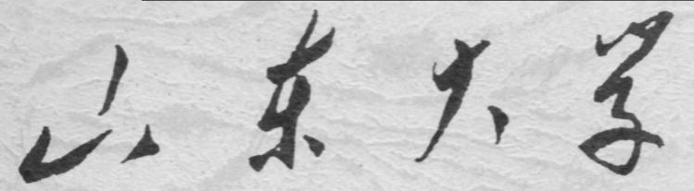

崇新学堂

2025－2026学年第一学期

实 验 报 告

课程名称： 电子信息工程导论
实验名称： Turning Heads

专 业 班 级 崇新学堂
学 生 姓 名 高子轩，钱竹玉，吕思洁，徐亚骐
实 验 时 间 2025年11月12日

Introduction
In this lab, our objective is to continue our work from Homework2 on the controller, design an electronic circuit for steering the head motor to seek and track a light source, using the photosensitive sensors for light detection.
Sensor design
Wk.8.4.1
Here are our answers
- If we want the output voltage to increase when the light level on the left photoresistor increases, left photoresistor should be connected to the 10 V supply.
- The output voltage ranges from 0 to 10 V.
- When the head is pointing directly at the light, 5 V voltage is produced.
- The output voltage decreases as the head turns counterclockwise, so that the right eye is brighter.
- The output voltage increases as the head turns counterclockwise, so that the right eye is brighter.

Here is the schematic circuit diagram
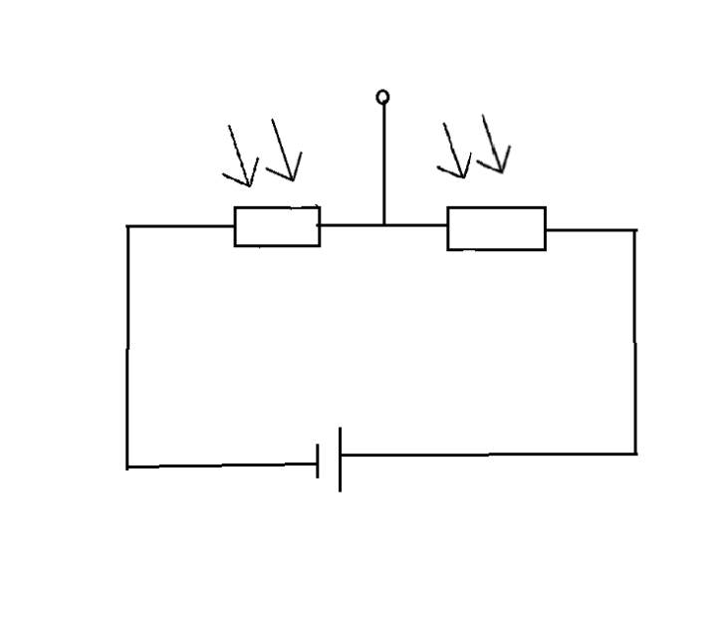
Figure 1 the circuit
The light seeker controller
Wk.8.4.2
To Non-Inverting Amplifier
- The expression for the intermediate voltage $V_{A}$:
$$V_{A}=V_{1}$$
- The expression for $K$:
$$K=1+\frac{R_{1}}{R_{2}}$$
- In a non-inverting amplifier, we can express $V$ and $K$ as follows:
$$V=V_{2}$$
$$K=1+\frac{R_{1}}{R_{2}}$$
4. Assuming that $V_{2}$ is 5V, that $R_{2}$ is 10 $KΩ$, and that $V_{1}$ is in the range 0V to 10V, we can determine the output voltage and record it in the
table below.
$V_{1}$ | $V_{2}$ | $R_{1}$ | $V_{o}$
10 | 5 | 100 | 5.0
7 | 5 | 100 | 5.0
5 | 5 | 100 | 5
3 | 5 | 100 | 5.0
0 | 5 | 100 | 5.1
10 | 5 | 10,000 | 0
7 | 5 | 10,000 | 3
5 | 5 | 10,000 | 5
3 | 5 | 10,000 | 7
0 | 5 | 10,000 | 10
Table 1 the output voltage (To Non-Inverting Amplifier)

To Inverting Amplifier
- When $V_{1}$=0V, the expression for $K$:
$$K=-\frac{R_{1}}{R_{2}}$$
- In an inverting amplifier, we can express V and $K$ as follows:
$$V=V_{1}$$
$$K=-\frac{R_{1}}{R_{2}}$$
- Assuming that $V_{1}$ is 5V, that $R_{2}$ is 10 $KΩ$, and that $V_{2}$ is in the range 0V to 10V, we can determine the output voltage and record it in the table below.
$V_{1}$ | $V_{2}$ | $R_{1}$ | $V_{o}$
5 | 10 | 5000 | 2.5
5 | 7 | 5000 | 4
5 | 5 | 5000 | 5
5 | 3 | 5000 | 6
5 | 0 | 5000 | 7.5
5 | 10 | 20,000 | 0
5 | 7 | 20,000 | 1
5 | 5 | 20,000 | 5
5 | 3 | 20,000 | 9
5 | 0 | 20,000 | 10
Table 2 the output voltage (To Inverting Amplifier)

Wk.8.4.3
Objective: to pick good $k_{c}$ values for a range of different $k_{s}$ values
We designed this piece of code to implement the complete control model simulation and optimization process of a light tracking system. Firstly, a system model including sensors, controllers, motors, and integrators is constructed.
Then, the core function dominantPoleMagnitude is defined to quantify the system performance -- this function distinguishes real poles (returns the maximum magnitude to evaluate the convergence speed) and complex poles (returns a penalty value of 1.0 to avoid oscillation) by calculating the discriminant of the characteristic equation.
Finally, the optimize.optOverLine algorithm is used to scan and optimize within the range of $k_{c}$ ∈ [0, 0.65], and the optimal controller gain $k_{c}$ = 0.625 is found, which enables the system to converge at the fastest speed without oscillation. At this point, the magnitude of the dominant pole is minimized to 0.9375, perfectly achieving the optimal control under the critical damping state.

Here is the key code
def dominantPoleMagnitude(kc):
FOUR_K1 = 4.0 * KM_KS_OVER_RM * kc
D = K2_SQUARED - FOUR_K1
if D >= 0.0:
radical_term = T * math.sqrt(D)
z1 = (TWO_MINUS_TK2 + radical_term) / 2.0
z2 = (TWO_MINUS_TK2 - radical_term) / 2.0
return max(abs(z1), abs(z2))
else:
return 1.0

Here are our answers
By running the above code, we know that under the conditions of $k_{m}$ = 250, $k_{b}$ = 0.48, $r_{m}$= 4.5, and T = 0.02, the sensor gain $k_{c}$ corresponding to different $k_{s}$ values is obtained. The results are as follows:

$$k_{s}$$ | Mag dominant pole | $$k_{c}$$
1 | 0.9714 | 0.6494
2 | 0.9389 | 0.6494
3 | 0.9001 | 0.6494
4 | 0.8491 | 0.6494
Table 3 the sensor gain $k_{c}$

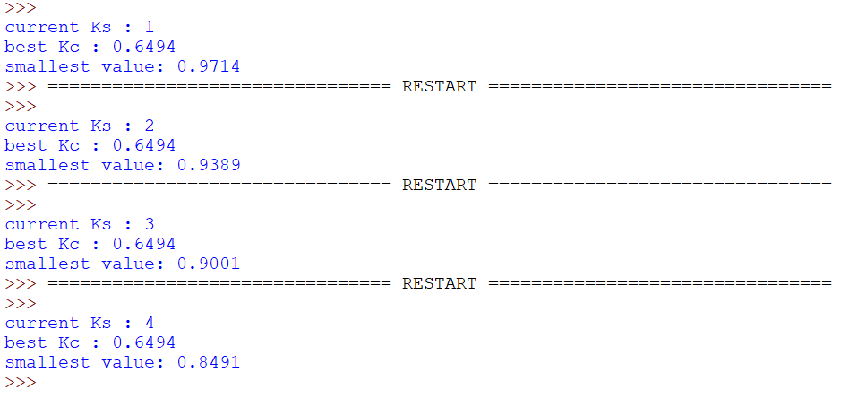
Figure 2 the value of the output gain, $k_{c}$

Wk.8.4.4
Objective: upload circuit diagram, CMax circuit code and explain
Here is the schematic of the simulation circuit
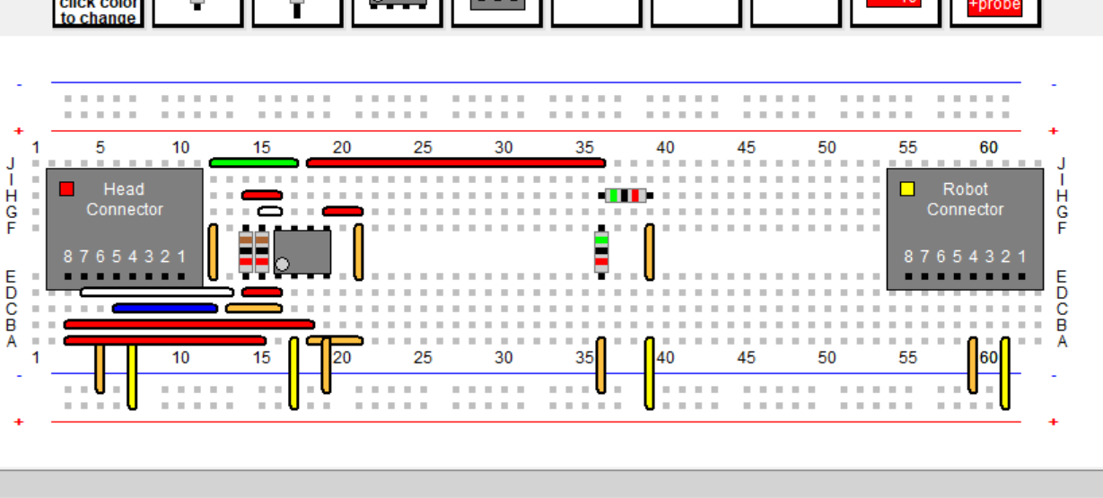
Figure 3 CMax Simulation Circuit

Here is the CMax circuit code
The two endpoints of the head connector are used to connect the left and right photoresistors. The resistor below is used to form a voltage divider circuit. The operational amplifier's input receives the voltage difference from the head photoresistors, and its output is amplified through resistors to drive the motor. The robot motor interface receives the drive voltage output from the operational amplifier. Wires are used to build the feedback loop.
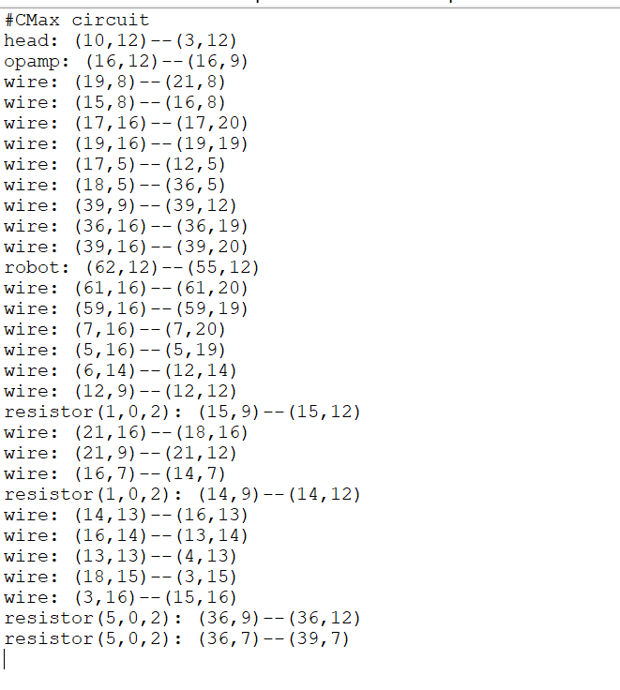
Figure 4 Circuit's Code

Here are the simulation results of the circuit obtained for different values.
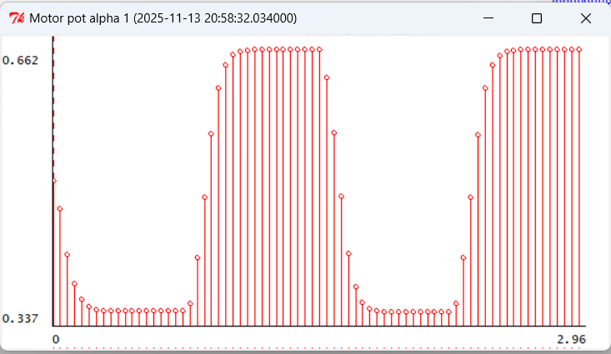
Figure 5 $k_{s}$= 0.5,${ k}_{c}$=2, eyeServo1
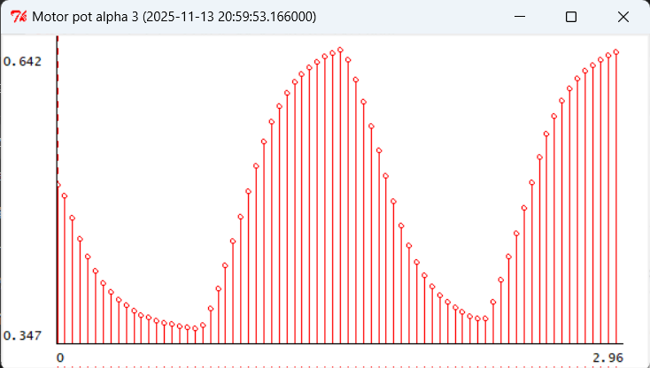
Figure 6 $k_{s}$=0.5,$k_{c}$=2, eyeServo3

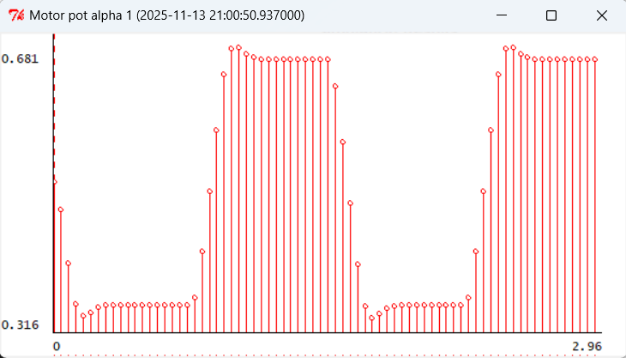
Figure 7 $k_{s}$=2, $k_{c}$=2, eyeServo1
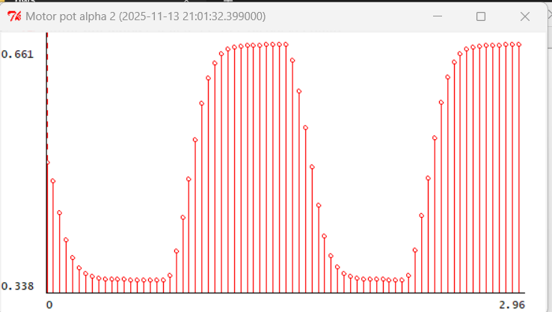
Figure 8 $k_{s}$=2,$k_{c}$=2, eyeServo3

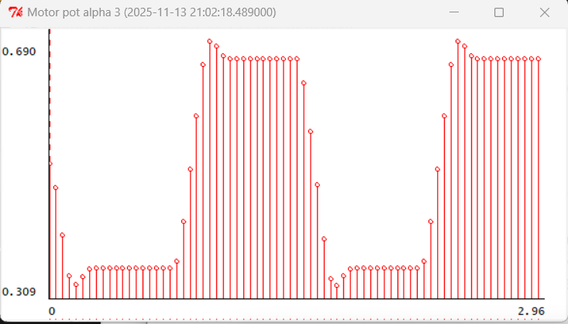
Figure 9 $k_{s}$=3,$k_{c}$=2, eyeServo1

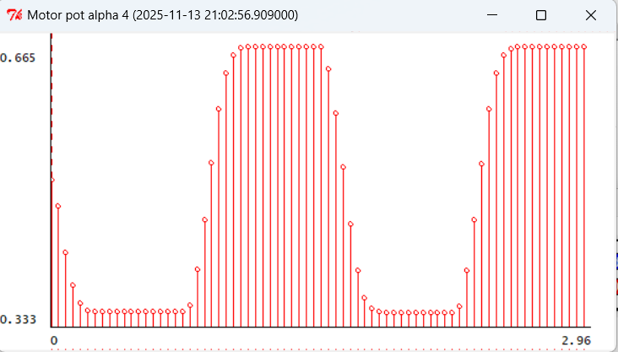
Figure 10 $k_{s}$=3,$k_{c}$=2, eyeServo3

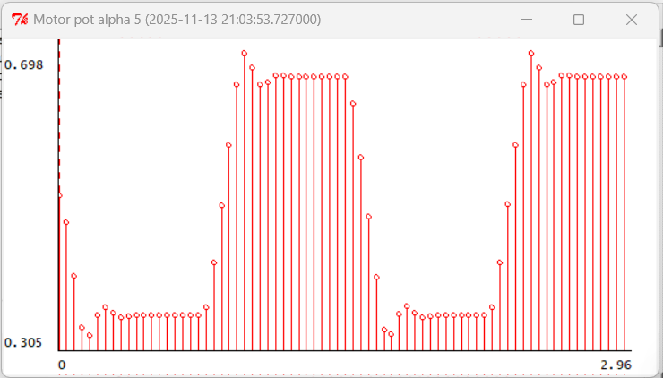
Figure 11 $k_{s}$=5,$k_{c}$=2, eyeServo1

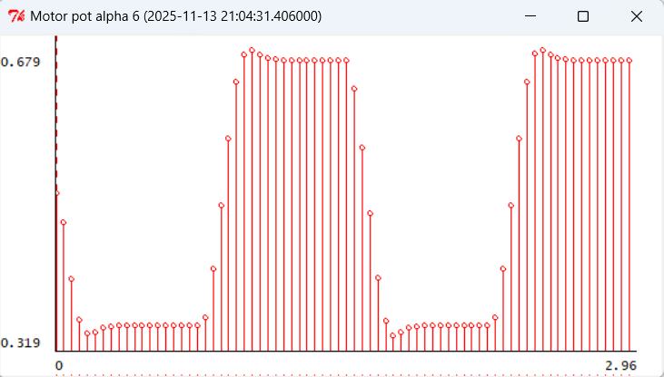
Figure 12 $k_{s}$=5,$k_{c}$=2, eyeServo3

Discussion
1. Critical Circuit Components
Light sensor circuit: Two phototransistors are connected in series with fixed resistors to form a voltage divider. The output voltages $V_{left}$ and $V_{right}$ represent the light intensity perceived by the left and right eyes respectively. When the head is facing the light, $V_{left}$ ≈ $V_{right}$; when the head turns to the left (the right eye becomes brighter), $V_{left}$ decreases and $V_{right}$ increases, and vice versa.
Differential Amplifier: The differential amplifier uses an operational amplifier circuit to calculate the difference between $V_{left}$ and $V_{right}$, and outputs the sensor signal $v_{s}$ = $V_{left}$ - $V_{right}$. According to HW2, $v_{s}$ is proportional to the angle difference, that is, $v_{s}$ = $k_{s}$ ($θ_{l}$ - $θ_{h}$), where ks is approximately 2.5 V/rad. The gain of the differential amplifier is set to 1 to ensure that $v_{s}$ directly reflects the angle difference.
Buffer: After the sensor output, a voltage follower (buffer) is added to isolate the sensor from the controller. The buffer provides high input impedance and low output impedance, preventing the controller load from affecting the accuracy of the sensor signal.
Proportional Controller: The controller input is $v_{s}$, and the output is the motor voltage $V_{motor}$. The design includes a 5V reference voltage (generated through resistor voltage division and buffer), such that when $v_{s}$ = 0, $V_{motor}$ = 5V (the motor stops); when $v_{s}$ > 0, $V_{motor}$ > 5V (the motor rotates forward); when $v_{s}$ < 0, $V_{motor}$ < 5V (the motor rotates backward). The gain kc is set through the feedback resistor and the input resistor, $k_{c}=1+\frac{R_{f}}{R_{i}}$
Motor drive: The controller output is directly connected to the M+ terminal of the motor, while the M- terminal is grounded. The voltage difference across the motor drives the head to rotate, thereby enabling the light seeking behavior.。

2. The buffer is required, for the following reasons:
High output impedance issue: The phototransistor itself has a relatively high output impedance. If the sensor output is directly connected to the controller (such as a differential amplifier), the input impedance of the controller will act as a load, causing the sensor voltage to be pulled down, thereby introducing measurement errors. Buffers can help mitigate this effect.
Signal integrity: The buffer provides high input impedance and low output impedance, ensuring that the VS signal is accurately transmitted to the controller. It can maintain the accuracy and stability of the system. Without a buffer, the sensor signal may be distorted, affecting the response of the controller and resulting in performance degradation.

3. The implementation method and selection rationale for gain $k_{c}$
The implementation method：We achieve the gain $k_{c}$ using a common-mode amplifier circuit.
Reason for selection：The symmetrical amplifier has a simple and stable structure, easy gain adjustment, and can naturally handle voltage offsets. This circuit is not only easy to implement and debug, but also can provide a stable low output impedance to drive the motor. It can also flexibly change the gain by adjusting the resistors to adapt to different${ k}_{s}$ values. At the same time, its structure naturally supports the introduction of a reference voltage, and can achieve bidirectional control of the motor without additional circuits, perfectly meeting the design requirements.

4.Revelation of circuit performance by simulation
When the gain $k_{c}=2$, the system achieves the optimal balance among rapidity, stability, uniformity and accuracy. Under this gain, the system responds quickly without significant oscillations, and can accurately point to the light source. Moreover, thanks to the differential amplification structure, the system is insensitive to changes in light intensity and distance, and shows uniform performance. Although increasing the gain can further enhance the speed, it will cause oscillations, while reducing the gain will result in a slow response. Therefore, $k_{c}$ = 2 has been verified as the optimal choice for achieving all design goals, and the adjustable gain design of the circuit enables it to flexibly adapt to different $k_{s}$ values.

Appendix1: Partial Content Description
Due to some issues with the robot, we were unable to obtain the measurement data, so the report omitted the part that required actual measurements.
Appendix2: The Description of AI Usage in the Report
In some parts, to ensure accuracy, we have used AI to help us translate and understand the content. Additionally, we have used AI to check the circuit design for us.

